INTRODUCTION

Heathkit used the National LM3911 temperature sensor in their ID-1490, ID-4001, ID-5001 and probably a few other models that monitored indoor and/or outdoor temperature. The Heathkit part number of the module was typically a 100-1727 or a 100-1728. The LM3911 was a single chip that would output a 10-mV change for every degree of change in temperature. Unfortunately the LM3911 is no longer available and even small quantities have disappeared from surplus dealer's and distributor's shelves.

The LM3911 can however be duplicated using a discrete solution of the currently available National LM335 temperature sensor, LM741, 6.8 Volt zener diode, and one resistor. The circuit was taken directly from the National LM3911 datasheet.

This kit provides the necessary components to build a replacement temperature sensor that can be directly substituted for the aluminum "tube" shaped temperature sensors that were used on the above kits. All of the components have already been mounted on the board and the board has been tested. All that remains is to attach the new board to the old cable, and seal the completed assembly with silicon seal.

The only difference between the 100-1727 (Outdoor) and the 100-1728 (Indoor) was that the "Outdoor" probe included an RF choke to reduce RF interference to the A/D converters. This replacement kit uses a "thin wall" aluminum tube for the bodies of the temperature probes.

The only tools needed are a low wattage soldering iron, wire cutters/strippers, and a tube of GE Silicon Seal available from any local hardware store. The GE Silicon Seal comes in a large caulking type cartridge and is just too big to include in the kit. You may already have some GE Silicon Seal around the house. Make sure that the silicon seal is fresh and will adhere to both the aluminum tube and the cable. If in doubt, use a new tube, it's not that expensive. I used the "aluminum" colored silicon seal, however, the color is not critical. If you decide to use a substitute, make certain the sealer is not electrically conductive. Also make certain that the substance will remain pliable with temperature and humidity changes. The sealer should be able keep the final assembly free of moisture and dirt to ensure many years of service.

INSTALLATION

The temperature probe has already been assembled and tested to ensure that it currently functions properly. To complete the assembly it will be necessary to remove the old sensor by cutting the existing cable approximately 6 inches from the existing sensor. The remaining 6 inches can be used to re-attach the old probe, should you feel it necessary for troubleshooting or whatever reason.

Probe Installation

First slide the insulating tubing over the end of the cable. Now you will need to attach the wires from the old cable to the new PC board as follows:

White Wire Connects to - (Minus)

Black Wire Connects to + (Plus)

Shield Connects to Remaining Pad (Center)

Slide the insulating tubing back down the cable and over the PC board to insulate the edges from shorting against the aluminum container.

Indoor vs. Outdoor Probes

Heathkit’s original design included an RF choke in the outdoor temperature sensor only. My new PC board includes an RF choke in the output of the LM741 as standard. This same configuration can be used for the indoor probe as well with no adverse results. You may use the current design of the replacement probe as either an ‘indoor’ or ‘outdoor’ replacement.

Preliminary Testing

When the probes are connected to their respective cables, you should temporarily connect the probes to your unit and ensure that they are functioning properly. You should get some "reasonable" reading. Remember that they have not yet been calibrated, but should respond with a change in temperature when heated or cooled. Variance from unit to unit is more a result of the variance in the reverse voltage of the zener diodes not the actual temperature sensors.

After you have confirmed that each probe is at least working, we will move on to the final stage of assembly. This stage will permanently seal the sensor against moisture and dirt, but it will also make it impossible to troubleshoot or make any repairs. Make certain that the soldered connections that you have done are reliable, as you will not be able to get to the connections later.

FINAL ASSEMBLY

Now that the probe is electrically attached to the cable, it is necessary to mechanically secure the probe and wire into the sensor housing. Make sure that the insulating tubing is covering the PC board so as not to short against the aluminum tube. First apply a small amount of silicon seal to the temperature sensor itself. This will act as both a glue as well as a thermal conductor between the sensor and the aluminum tube.

Place the sensor board into the aluminum tube making sure that the sensor is against the inside tip of the aluminum tube. Once this has been done, you can now fill the back of the tube with silicon seal. Make certain that there is good adherence of the silicon seal to the existing cable and the insides of the tube. This should create a watertight seal. Stand the probe on end and allow all of the silicon seal to cure completely. This will take a couple of hours. Letting it stand overnight is best.

Your temperature sensor is now ready to be calibrated and put into use. Follow the calibration instructions for your particular kit. This typically includes submersing the probe into a hot water bath of a known temperature and an ice/water bath that should be fixed at 32 degrees Fahrenheit.

Variance between probes

The LM335 ideally has an output voltage of 2.98 volts at 25 degrees Celsius relative to its common lead. The variation from one part to another can range from 2.97 volts to 2.98 volts at 25 degrees Celsius. This represents a voltage variance of 20 mV, which equates to only 2 degrees Celsius or 3.6 degrees Fahrenheit. This is totally within the calibration range of the ID-4001. The LM3911 had a similar range of variance between different parts. The biggest contributor to variance is the reverse voltage of the zener diode. When probes are bought in pairs, I will try to supply two probe kits with the same measured zener voltage. This however, should not be critical because all of the Heathkits had individual slope and intercept controls for each temperature input.

In some rare cases, we have seen that the discrete implementation of the LM3911 will draw a little more current than the ID-4001 can supply using the existing resistor bridge circuit. In those rare cases, replacing R201 and R216 (9100) with a 4700 and replacing R202 and R217 (6200) with a 3300 will provide additional current to the probes. These new values will keep the bridge at the same voltage point while allowing more current to flow to the temperature sensor.

PICTURES

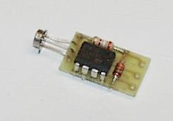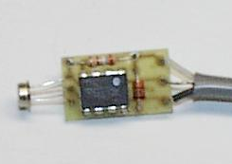
Temperature Sensor Board w / Cable attached

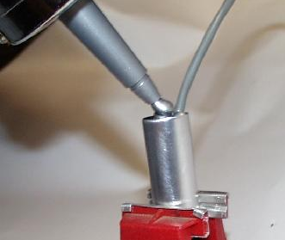
Assembly being permanently "sealed"

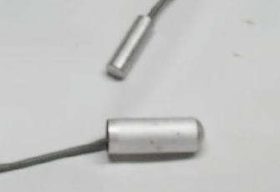
Comparison of original (Top) and the new (Bottom) temperature probes (These were the older larger aluminum tubes, the newer ones are about the same size as the originals.)

